Institution Details

Province | Sindh | City | Karachi
Institution | National University of Computer and Emerging Sciences (FAST-NU) | Campus | Karachi
Department | Computer Science | Degree Level | BS
Degree Program | Computer Science | Telephone
Fax

Supervisor Details
Name | Saeeda Kanwal | Gender | Female
Mobile | +92 336 8458203 | Office No
Email | Saeeda.Kanwal@nu.edu.pk | Designation
Qualification

Co-Supervisor Details
Name | NA | Gender | NA
Mobile | NA | Office No | NA
Email | NA | Designation | NA
Qualification | NA

Head of Department Details

Name | Dr. Zulfiqar Memon | Mobile No. | -
Email | zulfiqar.memon@nu.edu.pk | Gender | Male

Project Details

Project Title | StudyMateAI
Group Details | Member 1 Name: Fawaz Ahmed  Member 1 Roll#: k21-4717 |  | Member 2 Name: Shahzaib Mirza  Member 2 Roll#: k21-3819 |  | Member 3 Name: Muhammad Daniyal  Member 3 Roll#: k21-4723
Project Area of | LLM(Large Language Model), NLP(Natural Language Processing), web development
Specialization
Project Start | 18th September, 2024 | Project End Date |  | June, 2025 (tentative)
Date
Project | StudyMateAI is an innovative AI-powered student management system developed to elevate the educational experience for teachers, parents, and students. By leveraging cutting-edge AI technology, StudyMateAI offers a range of core functionalities designed to streamline learning and teaching processes. It can automatically generate comprehensive quizzes, and practice exams from input documents such as textbooks or pdf, saving valuable time for educators and providing students with customized study materials. Additionally, StudyMateAI can summarize educational videos, distilling key points and concepts to facilitate quick understanding and revision. Through its intelligent features, StudyMateAI aims to create a more engaging, efficient, and personalized learning environment.
Summary (less
than 2500
characters)
Project | - Automate Study Material Generation: Build an AI system to generate quizzes, exams, and customized study materials from input documents.  - Enhance Video Learning: Implement AI-driven video summarization to extract key concepts for quicker revision.  - Personalize Learning Experiences: Tailor study material recommendations based on students' progress and learning needs.  - Improve Teacher Efficiency: Reduce educators' administrative workload by automating quiz creation, allowing more focus on teaching.  - Simplify Parent Involvement: Provide parents with an interface to monitor their child’s academic progress and engagement.
Objectives (less
than 2500
characters)
Literature Review / Background Study | The integration of AI in education has revolutionized learning by automating tasks such as content generation. AI technologies, such as Natural Language Processing (NLP) and machine learning, enable automated quiz generation from input documents like PDFs and textbooks.  AI-based video summarization is another key advancement. Techniques such as extractive and abstractive summarization allow for the condensation of lengthy educational videos into key points, improving learning retention and quick revision.  Personalized learning systems have become a cornerstone of modern education, adapting study materials based on individual student performance. These systems employ machine learning models to analyze progress and recommend targeted content, thus enhancing learning outcomes and efficiency.  Furthermore, platforms that allow parents to monitor academic progress help foster better communication between parents, teachers, and students, contributing to improved student performance.
Project Implementation Method (less than 2500 characters) | System Architecture and Methodology  The StudyMateAI system is built around several core modules:  - Input Processing: NLP algorithms extract key content from documents.  - Quiz Generation: AI generates quizzes and study materials from input content using pre-trained NLP models.  - Video Summarization: AI summarizes educational videos by extracting key points, aiding in quick revision.  - Personalization Engine: Machine learning monitors student progress and tailors study recommendations based on performance.  - Parental Dashboard: A user-friendly interface for parents to track their child's academic progress.  Methodology  - Requirement Analysis: Understanding user needs (teachers, students, parents) to define core functionalities.  - Data Collection: Gathering educational content and student performance data for model training.  - Model Training: Fine-tuning NLP and video summarization models for quiz creation and key concept extraction.  - System Integration: Ensuring smooth interaction between modules.  - Testing and Validation: Testing with real users to optimize quiz generation, video summarization, and personalization features.  - Deployment: Launching the system with ongoing improvements based on user feedback.  This concise approach ensures that StudyMateAI efficiently automates and personalizes the learning process
Benefits of the | The StudyMateAI platform offers several groundbreaking benefits that address limitations in existing educational tools, providing enhanced functionality and a more accessible experience.  1. Free and Accessible  Unlike most existing tools that are behind paywalls, StudyMateAI is completely free to use, making high-quality educational resources accessible to all students and teachers regardless of financial constraints.  2. Expanded PDF Upload Capacity  Existing products restrict the number of pages or characters users can upload (typically 50-100 pages or a few thousand characters). StudyMateAI removes these limits, allowing users to upload larger documents without compromising on content, ensuring that all learning materials can be processed in one go.  3. Answer Validation and Explanations  StudyMateAI offers answer validation, providing detailed explanations for incorrect answers. This feature is rarely available in existing tools and plays a crucial role in improving student comprehension by not just marking answers wrong but explaining why.  4. Targeted Quiz Generation  Most platforms generate quizzes based on entire documents, which can be overwhelming and inefficient. StudyMateAI introduces the ability to create quizzes from specific sections, page ranges, or topics, allowing for more focused and effective learning based on particular study areas.  5. Customizable Timed Quizzes  Unlike current systems, which lack time-management features, StudyMateAI allows users to set a custom timer for quiz attempts. This feature promotes effective time management, helping students practice completing tasks within a set timeframe—an essential skill for exams and real-world challenges.  6. Personalization and Flexibility  StudyMateAI’s core AI-driven functionality enables personalized quiz generation, tailored explanations, and flexible learning options, setting it apart from rigid, one-size-fits-all solutions. The platform adapts to individual learning needs, enhancing the overall educational experience.  Conclusion  By addressing the limitations in existing products, StudyMateAI revolutionizes the educational landscape with a free, accessible, and highly functional platform. Its unique features expanded upload capacity, targeted quiz generation, answer validation, and time management support ensure a more personalized, efficient, and effective learning experience.
Project (less
than 2500 characters)

Technical | The final deliverable for StudyMateAI is an AI-powered educational platform designed to automate and personalize learning. Here are the technical details:  1. System Architecture  Backend: Built with Python-based frameworks (e.g., Flask or Django) to handle data processing, model integration, and user management.  Frontend: Developed using HTML, CSS, and JavaScript for a responsive and user-friendly interface.  Database: A relational database (MySQL) stores user data, performance metrics, and content.  2. Core AI Modules  Quiz Generation: Pre-trained language models (Lama or BERT) generate quizzes from input documents such as PDFs and textbooks.  Video Summarization: Speech-to-text combined with extractive or abstractive summarization techniques generates concise transcripts of educational videos.  Personalization Engine: Machine learning models analyze student performance data to recommend study materials, tailoring quizzes and resources based on progress.  3. APIs and Integrations  Document Processing API: Extracts content from documents and feeds it to the NLP model for quiz generation.  Video Processing API: Converts video speech to text for summarization.  4. User Interfaces  Teacher Dashboard: Allows educators to upload documents/videos for quiz generation and video summarization, with the ability to modify content before sharing.  Student Interface: Displays personalized quizzes, video summaries, and progress reports, offering real-time feedback and recommendations.  Parent Dashboard: Enables parents to monitor student performance, quiz results, and academic engagement.  5. Security and Data Privacy  User Authentication: Uses JQuery or JWT tokens for secure login and data protection.  Data Encryption: Ensures sensitive data (e.g. student progress) is encrypted in transit and at rest.  6. Performance Monitoring  Analytics Dashboard: Provides real-time monitoring of system performance, user engagement, and content effectiveness.  Logging and Alerts: Tracks errors and performance metrics for quick issue resolution.  Final Deliverable Summary  The deliverable is an AI-powered platform offering NLP/LLM-based quiz generation, video summarization, and personalization features. It includes dashboards for teachers, students, and parents, ensuring an efficient, engaging, and secure educational experience.
Details of Final Deliverable (less than 2500 characters)
Final Deliverable of the Project | The final deliverable for StudyMateAI is a comprehensive AI-powered educational platform designed to automate the creation of personalized study materials, including quizzes, and improve the learning experience for students, teachers, and parents. The platform integrates cutting-edge AI technologies to deliver key features that address gaps in existing educational tools.  Key Features:  1. Free Access: The platform will be entirely free, removing financial barriers for educators and students.  2. Unlimited PDF Uploads: Users can upload larger PDFs, surpassing the page and character limits found in other systems.  3. Targeted Quiz Generation: Quizzes can be generated based on specific sections, page ranges, or topics from documents, rather than from the entire document.  4. Answer Validation and Explanations: The platform will validate answers and provide explanations for incorrect responses to improve student comprehension.  5. Customizable Timed Quizzes: Users will be able to set a timer for quizzes, helping students practice time management skills.  6. User Dashboards:  Teachers: Add student’s numbers and attendance, and view student progress.  Students: Upload PDFs, generate quizzes, access study materials and personalized progress reports.  Parents: Monitor student progress and engagement.  The final deliverable is a feature-rich, AI-driven platform that supports personalized and efficient learning experiences while promoting better engagement and understanding for all users.
Core Industry (Optional) | As suggested by Supervisor
Other
Industries
(Optional)
Core | NodeJS, ReactJS, Python, Mysql, Flask
Technology
Other
Technologies
(Optional)
Sustainable
Development
Goals
(Optional)
References

Project Key Milestones
Elapsed time in (days or weeks or month or quarter) since start of the project |  | Milestone | Deliverable
Month 1
Month 2
Month 3
Month 4
Month 5
Month 6
Month 7
Month 8

System Diagram
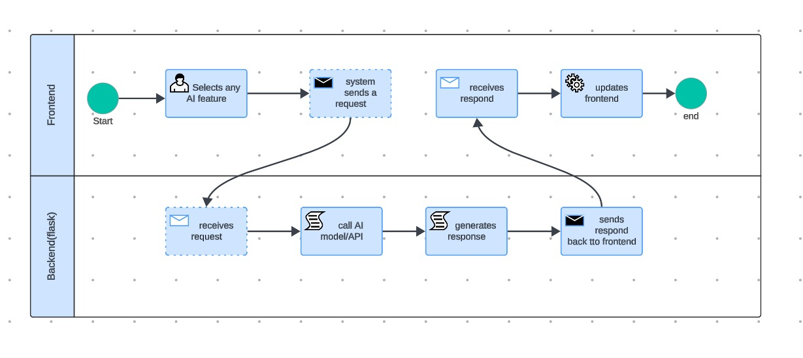
Project Equipment Details

Item(s) Name | Type | No. of Units | Per Unit Cost (in Rs) | Total (in Rs)
 |  |  | Total in (Rs)

